B.Tech 3rd Sem
JAVA Assignment -1
- Write a program to display your name, branch, roll no, and college name on the computer screen.
- Write a program to display the addition result of two numbers 10.25 and 20.55 on the screen.
- Write a program to input two floating point numbers through the keyboard and display their sum.
- Write a program to swap two numbers without using a third variable.
- Write a program to check a number is odd or even.
- Write a program to input the marks of a student in three different subjects and then display the average mark.
- Write a program to input the time value in seconds and then display it in the hour: minute: second format using the modulus operator (%). For example, INPUT: Enter the time in second: 3610
OUTPUT: 1Hour: 0 minute: 10 seconds
- Write a program to reverse a number.
- Write a program to check a number is prime or not.
- Write a program to find out the sum of the individual digits of a number.
- Write a program to check whether an inputted number is positive or negative.
- Write a program to test whether a number is positive, negative or equal to zero.

Assignment-2
Topic: Decision Making Statements, Looping and Function
- Write a program to calculate tax, given the following conditions:
  - If income is less than 150000 then no tax
  - If taxable income is in the range 150001 to 300000 then charge 10% tax
  - If taxable income is in the range 300001 to 500000 then charge 20% tax
  - If taxable income is above 500001 then charge 30% tax
- Write a program to enter the marks of a student in 4 different subjects. Then display the grade of the student as per the following conditions:
  - If the average mark is greater than or equal to 90 then grade is O
  - If the average mark is greater than equal to 80 but less than 90 then grade is E
  - If the average mark is greater than equal to 70 but less than 80 then grade is A
  - If the average mark is greater than equal to 60 but less than 70 then grade is B
  - If the average mark is greater than equal to 50 but less than 60 then grade is C
  - If the average mark is less than 50 then grade is F
- Write a program to calculate the roots of a quadratic equation.
- Write a program to enter a number from 1 to 7 and display the corresponding day of the week using switch statement.
- Write a program to find out the factorial of any inputted number.
- Write a program to check whether an inputted number is prime or not.
- Write a program to check whether an inputted number is palindrome or not.
- Write a program to find out the binary equivalent of any inputted decimal number.
- Write a program to display all Armstrong numbers from 1 to 10000.
- Write a program to find out the largest between two numbers using a conditional operator.
- Write a program to find out the largest between three numbers using the conditional operator.
- Write a recursive program to find the sum of n natural numbers. [ n is user input ]
- Write a recursive program to find the GCD of two inputted numbers.

Assignment-3
Topic: Array, Command-line arguments
- Write a program to search an element present in the array.
- Write a program to sort the array of n elements.
- Write a program input two matrices and perform the addition of two matrices.
- Write a program that performs the addition of two numbers using command-line arguments.
- Write a program that will take two integer numbers from the command prompt and find their GCD. If the user does not provide exactly two numbers of arguments then the program should display error message.
- Write a program that will take employee id, employee name, department number, salary from the command prompt. If the user does not provide exactly two numbers of arguments then the program should display error message. Use methods display() to display the record of employee.
- Write a program to accept the SIC, name, branch and marks of six subjects using command line argument. Calculate the average marks.
- Write a program to input a jagged array and display it.

Assignment No: 4
Class and Object, Constructor, this and static
- Write a program to print the average of three numbers entered by user by creating a class named 'Average' having a method to calculate and print the average. Define another driver class to demonstrate the basic operation.
- Write a program to create a class named 'Student' with members 'name', 'roll_no', ‘branch’. Declare two methods to input the student details and display the details of the student. Create a driver class to test the functionalities of the above class.
- Declare a class Complex with member real and imaginary part. Define a method initialise() to input the two complex numbers, show() to display the complex number and add() to add the two complex numbers. Declare another class to illustrate the operations of the Complex class.
- Write a program to print the area of a rectangle by creating a class named 'Area' having two methods. First method named as 'setDim ()' takes length and breadth of rectangle as parameters and the second method named as 'getArea ()' returns the area of the rectangle. Length and breadth of rectangle are entered through keyboard. [use ‘this’ keyword]
- Write a program to declare a class employee with data members empid, ename, dept, sal. Add a method getData(), putData() to accept and display the details of n employees. Define a driver class to create the objects of employee class and perform basic operations.
- Define a class Student having the attribute regNo, stdName, branch and CGPA. Write 2 methods to accept and display the student details. Read the details of 50 students using an array of Student class object. Display the student details who has secured the highest CGPA.
- Define a class ‘Box’ that uses a parameterized constructor to initialize the dimensions of a box. The dimensions of the Box are width, height, depth. The class should have a method that can return the volume of the box. Create an object of the Box class and test the functionalities[use this keyword].
- Design a class ‘ComplexNum’ to manipulate Complex numbers having data members as real and img. The class should have a parameterized constructor to initialize its data members. It should also have methods displayCompNumber() to display the complex number (in the format 5+3i for example), addCompNumber() to add two Complex numbers. Test these methods by creating main method in another class.
- Design a class ‘Point’ with data members as xCo and yCo. The class should have a parameterized constructor to initialize its data members. Define a method distanceBetPoints() which returns the distance between two points.
- Design a class ‘Time’ having data members as hour, minute and second. The class should have a parameterized constructor to initialize its data members. It should also have methods displayTime() to display the time in HH:MM:SS format and addTime() to add two times. Test these methods by creating a main method in another class.

Assignment No:5 Topic : Inheritance, Abstract Class
- Write a program that creates a class Account that have members customer name, account number. Account has constructor to initialize its members and method display() to show the result. Create a child class Savings_Account that is derived from Account class. Savings_Account have members min_bal and saving_bal. Use show() to display its details. Then create another child class Account_details from Savings_Account class have members deposit, withdrawl and a method show1() to show its details. Child classes have constructors of their own. Create a driver class that creates a record of customer and display all its details.
- Create a class Figure with instance members dim1 and dim2. Use constructor and area() that returns the area of figure. Create a derived class Rectangle derived from Figure and area() that returns the area of rectangle. Create another derived class Triangle and Square that has area() which returns area of Triangle and Square respectively. Derived class have appropriate constructor. Using method overriding concept test the functionalities of derived class by creating objects and super class memory references in Driver class.
- Write a program to create a class named Shape. It should contain two methods, draw() and erase() that prints “Drawing Shape” and “Erasing Shape” respectively. For this class, create three sub classes, Circle, Triangle and Squareand each class should override the parent class functions - draw () and erase (). The draw() method should print “Drawing Circle”, “Drawing Triangle” and “Drawing Square” respectively. The erase() method should print “Erasing Circle”, “Erasing Triangle” and “Erasing Square” respectively. Create objects of Circle, Triangle and Square, assign each to Shape variable(reference) and call draw() and erase() method using each object.
- Define an abstract class named “Figure”, having data members dim1 and dim2. Extend this class to create two concrete classes named Rectangle and Triangle. Override the getArea() method in the sub classes. Invoke the getArea() method in the main method of another Driver class through the abstract class reference variable.
- Create a class Point2D with the data member x and y coordinate. Use default and parameterised constructor to set the coordinate values and display() to show the coordinates. Create a subclass called Point3D which is derived from the superclass Point2D with data members z coordinate and has constructor to initialize the input and show() method to display the coordinates. Test the methods of both the classes by creating objects in the main method of driver class.
- Create the classes as given in the below figure. Display the interest rate in the following format:
SBI Rate of Interest : 8
ICICI Rate of Interest : 7
AXIS Rate of Interest : 9
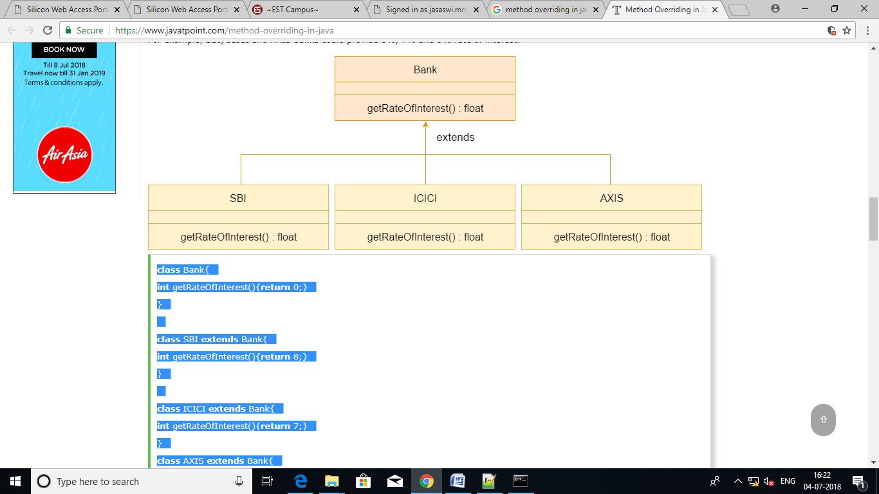
- Create a class Person that has data member name. Use constructor to initialize name and display() to display name. Create a derived class Employee from Person class having private members empid. Using constructor initialize empid and have method display() to display empid. Create another derivedclass HourlyEmployee from Employee with private members hourlyRate and hoursWorked. Use constructor to initialize input and methods getGrossPay() that computes and returns the gross pay of the employee and display() to display the hourlyRate, hoursWorked and gross pay. Create a driver class to test the functionalities of the above classes and display output in the following format
Name : John Smith
EmpID : 7569
Hourly Rate : 100
Hours worked : 2000
Gross pay : 200000

Assignment No:6
Topic :Abstract Class, Interface, Package
- Create a abstract class Bank that has abstract method getROI(). Create two classes SBI, PNB, BOI inherited from Bank. Create a driver class that prints the rate of interest of each bank using super class memory reference.
- Define an interface Calculator which has the basic methods add(), sub( ), mul() and div(). Define a concrete class named as DemoCalculator that implements the interface. Define the driver class, which create object reference of the interface Calculator and perform all basic operation of the calculator.
- Create an abstract class 'Shape' with three abstract methods namely 'RectangleArea' taking two parameters, 'SquareArea' and 'CircleArea' taking one parameter each. The parameters of 'RectangleArea' are its length and breadth, that of 'SquareArea' is its side and that of 'CircleArea' is its radius. Now create another class 'Area' containing all the three methods 'RectangleArea', 'SquareArea' and 'CircleArea' for printing the area of rectangle, square and circle respectively. Create an object of class 'Area' and call all the three methods.
- Write a program to implement multiple inheritance using interface.
- Create an interface Servicing that has abstract methods getServiceTime(). Create two class Car, Bike that implement interface. Create a driver class that creates the objects of two class and displays the service time.
- Create a Package btech which has one class Student. Accept student detail through parameterized constructor of Student class. Write a method display()to display the student details. Create another class Test containing the main method which will use the package btech and calculate total marks and percentage of marks. One sample output is shown below.
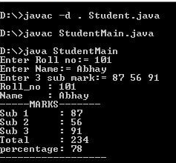
- Create a sub-package called arithmetic under the package btech. The arithmetic package should contain a class MyMath having methods to deal with different arithmetic operations (addition, subtraction, multiplication, division and mod). Create a class Test containing the main method which will use the methods of sub-package arithmetic.
- Create a sub-package named shapesunder a package org. Create some classes in the package representing some common geometric shapes like Square, Triangle, Circle and so on. The classes should contain the area( ) and perimeter( ) methods in them. Compile the package. Use this package to find area and perimeter of different shapes as chosen by the user.

Assignment-07
Topic: Exception Handling in Java

- Write an exception handling java program to read two numbers n1, n2 and calculate and print the result of n1/n2. If n2 is Zero (0) then it will be handled by exception handler and again ask the value of n2. In the exception handler the program should display appropriate message to the user.
- Write a java program to read two numbers x and y and calculate x/(x−y). The program should check the value of x−y. Before dividing with x, it should throw an exception if x−y is zero. In the exception handler the program should display appropriate message to the user.
- Write an exception handling java program to print the index position of an existing integer array. The index value will be entered by user. It will be handled by exception handler if index position is greaterthen the size of array. In the exception handler the program should display appropriate message to the user.
- Write a program to illustrate the use of multiple catch blocks associated with a single try block.
- Write a class called Account with the following properties and methods:
Properties: String name, int acc_no, double balance
Methods: void deposit (double amt)
void withdraw (double amt)
Assume that an account needs to have a minimum balance of 500. If an attempt is made to withdraw, which results in balance going below 500, throw a user defined exception called MinimumBalanceException. Use throw and throws wherever necessary.
- Write a class called Account with the following properties and methods:
Properties: String name, int acc_no, double balance
Methods: void deposit (double amt)
void withdraw (double amt),
void transfer (Account acc1, Account acc2, double amt)
Assume that an account needs to have a minimum balance of 500. If an attempt is made to withdraw or transfer, which results in balance going below 500, throw a user defined exception called MinimumBalanceException. Use throw and throws wherever necessary.
- Write a program that prompts the user to enter a length in feet and inches and outputs the equivalent length in centimetres. If the user enters a negative number or a non-digit number, throw and handle an appropriate exception and prompt the user to enter another set of numbers.

ASSIGNMENT-08
TOPIC: MULTITHREADING

- Write a java program that will create the reference of the thread and display the details of the reference thread. (It should display class, name of thread, priority, group name)
- Write a java program that will create a thread and set the thread name, display the thread name, get the thread id, check the thread is currently alive or not.
- Write a java program that will create one thread [using Runnable interface]. The main thread will read a number and the newly created thread checks the number is Armstrong number or not.
- Write a java program that will create one thread [using extends]. The main thread will read a number and check the number is prime or composite and the same time the new thread will check the number palindrome or not.
- Write a java program that will create one child thread. The child thread has to display all odd numbers between m and n, and the main thread will display all the even numbers between m and n.
- Write a java program to create two threads. First thread should find the square of the number, second thread should find the sum of the digits of the number.
- Write a java program that will create two threads. The main thread will read a number and one thread will print the multiplication table of the entered number and the same time the other thread will find the factorial of the entered number.
Note: Main thread has to wait until other two threads have completed their task.
- Write a java program that will create two threads. Set the priority to each thread and display it.
- Write a java program that will compute product of two 1D arrays using multithreading. The program should read two 1D arrays of same size from the user. First thread should multiply the corresponding elements present in the odd index position and second thread should multiply the corresponding elements present in the even index position. Main thread should display the result.
- Write a simple Java thread program to compute the sum of n natural numbers. The program should read the number of threads m and value of n from the user. Each of the threads should add its share of assigned number to a global variable. When all the threads are done, the global variable should contain the result. The program should use a Synchronized block to make sure that only one thread is updating the global variable at a given time.
- Write a Java thread program to search the minimum number in a given array. The program should read the number of elements in the array, number of threads to be created and the array elements from the user. Each thread should find minimum element in an assigned block of elements and compare to global minimum element. When all the threads are done, the global variable should contain the minimum element. It should use a Synchronized block to make sure that only one thread is updating the global minimum variable at any given time
- Write a java program in which main thread should create two child threads (Producer and Consumer). First child thread (Producer) should produce ten random integers between 1 to 100 and the second child thread (Consumer) should check whether the generated number is even or odd. At the end the second child thread (Consumer) should print total number of even numbers received. Both the threads should wait and notify each other wherever necessary. The sample output is shown below:
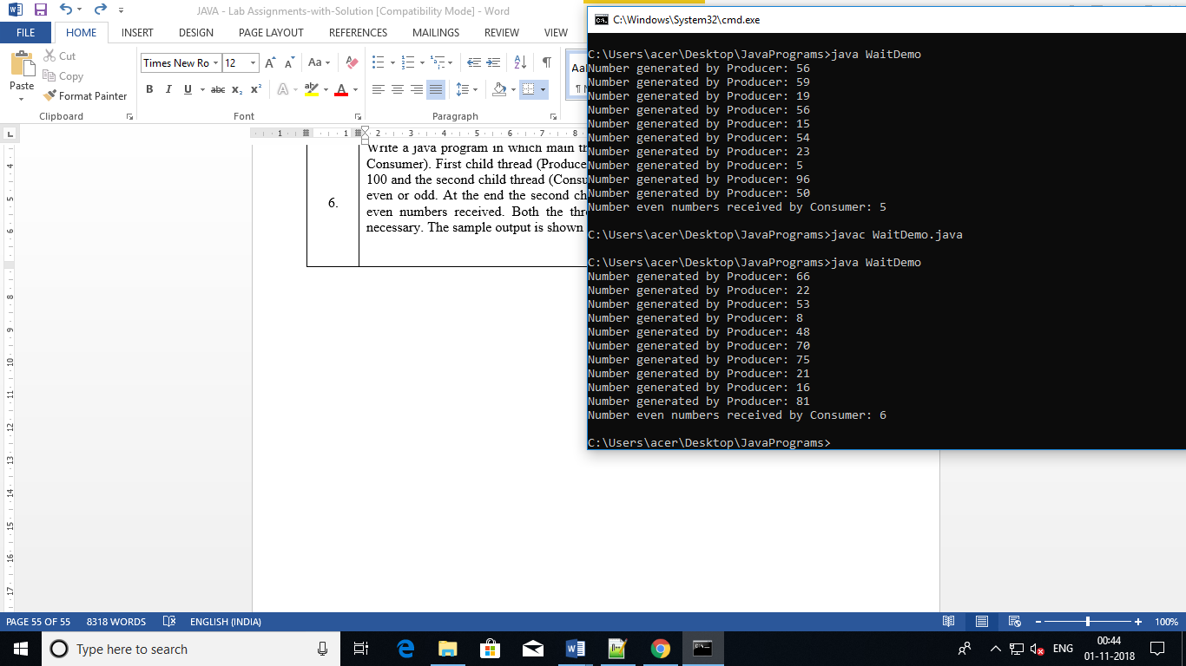

ASSIGNMENT- 08
TOPIC: STRING MANIPULATION

1. Write a JAVA program to read a string from the key board and print its reverse. Also check whether the string is palindrome or not.
2. Write a JAVA program to capitalize first letter of each word in an inputted sentence from keyboard.
Sample Output:
Enter a sentence: india is great
India Is Great
3. Write a JAVA program to convert a string into uppercase.
4. Write a Java program to input a string and print the total number of characters present in the string.
5. Write a java program to replace a substring with another string.
6. Write a program that computes your initials from your full name and displays them.
7. Write a program that receives two strings and check whether they are equal or not.

